Question 1
What is the optimal value of alpha for ridge and lasso regression? What will be the changes in the model if you choose double the value of alpha for both ridge and lasso? What will be the most important predictor variables after the change is implemented?
Answer:
For Ridge Alpha value chosen in 10. With Ridge regression at alpha =10, the top 10 most important variables were OverallQual, GrLivArea, TotRmsAbvGrd, OverallCond, 1stFlrSF, FullBath, 2ndFlrSF, GarageCars, Neighborhood_Crawfor, and GarageArea. These features highlight that house price is primarily driven by overall construction quality, total living area, number of rooms, physical condition, floor space distribution, bathroom count, garage capacity, and location. After doubling the regularization strength to alpha =20, the top 10 variables shifted slightly to OverallQual, TotRmsAbvGrd, GrLivArea, FullBath, OverallCond, 1stFlrSF, GarageCars, 2ndFlrSF, GarageArea, and Neighborhood_Crawfor. While the ranking of some variables changed, the core predictors remained the same, indicating strong model stability.
Increasing the value of alpha made the model reduce the strength of less important features. However, the main and most important features did not change. The top predictors were still related to house quality, house size, how usable the space is, and the desirability of the neighborhood.

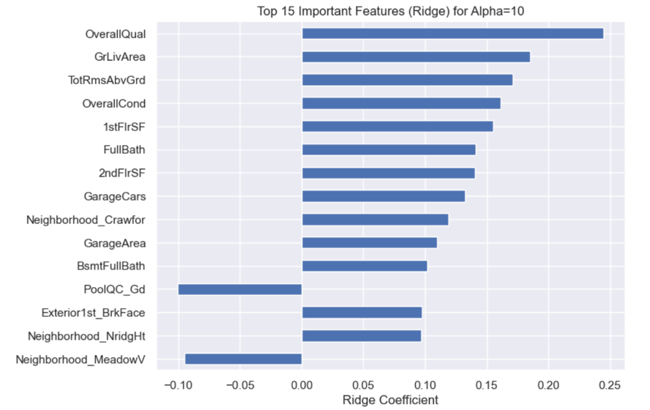

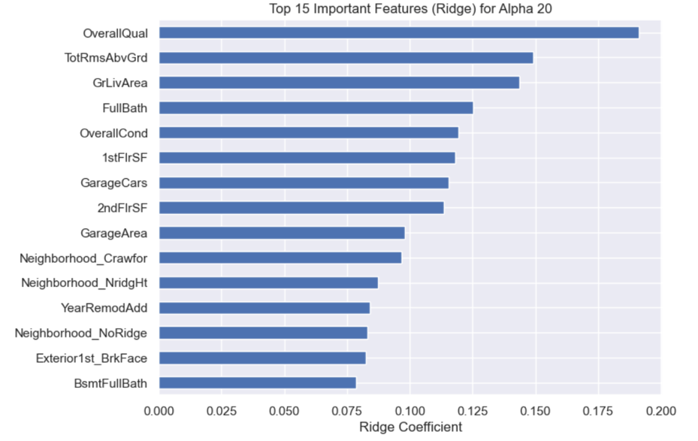

For Lasso: Alpha choosen is 0.001
When the alpha value is doubled in Lasso regression, the strength of regularization increases, which makes the model more selective. As a result, more coefficients are shrunk to zero, reducing the number of selected features from 87 to 62. This leads to a simpler and more interpretable model, but with a small trade-off in predictive accuracy. Doubling the Alpha value leads to underfitting
After increasing the Lasso alpha, the most important predictors of house prices are GrLivArea, OverallQual, GarageCars, TotRmsAbvGrd, OverallCond, BsmtFullBath, FullBath, Neighborhood_NridgHt, CentralAir_Y, and BsmtExposure_Gd, indicating that living area, quality, amenities, and location remain the key drivers of pricing.
With a lower alpha, the Lasso model is less strict and retains more features, including weaker predictors such as PoolQC_Gd and multiple neighborhood indicators. When the alpha is increased, these weaker features are removed, and the model focuses only on the strongest and most stable predictors like living area, overall quality, garage capacity, and key location and comfort features.
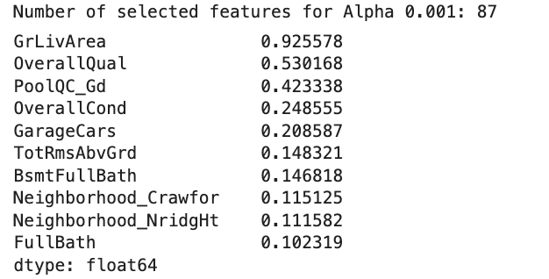

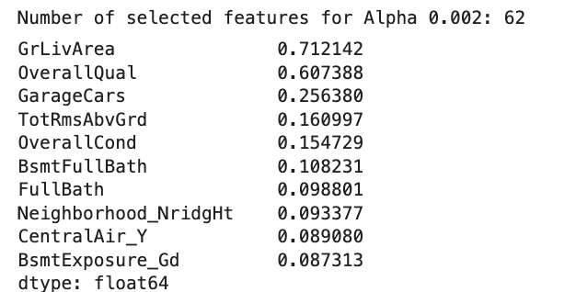
___________________________________________________________________________

Question 2
You have determined the optimal value of lambda for ridge and lasso regression during the assignment. Now, which one will you choose to apply and why?
We observe that both Ridge and Lasso models show very similar performance on the test data. Ridge performs marginally better, with a slightly higher test R² and lower RMSE, but the difference compared to Lasso is very small and practically negligible.
Despite this, Lasso is chosen as the final model because it provides the additional benefit of feature selection. While maintaining comparable prediction accuracy, Lasso reduced the original feature set from over 258 variables to ~90 important features, making the model simpler and easier to interpret. This helps in identifying the key predictors that influence house prices and supports better business decision-making.

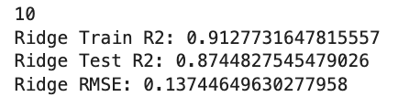

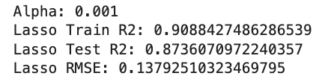
___________________________________________________________________________

Question 3:
After building the model, you realised that the five most important predictor variables in the
lasso model are not available in the incoming data. You will now have to create another
model excluding the five most important predictor variables. Which are the five most
important predictor variables now?
Answer:
For alpha value of 0.001 and using Lasso Regularization -
Earlier the most important factors were : This table shows the Variable and their coefficients
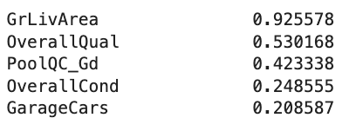
After removal of above variables most important variable using lasso are: (This table shows the Variable and their coefficients)
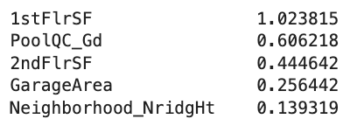
___________________________________________________________________________

Question 4:
How can you make sure that a model is robust and generalizable? What are the implications of the same for the accuracy of the model and why?
A model is robust and generalizable when it performs well not only on training data but also on new, unseen data. This can be achieved by using techniques like train–test split, cross-validation, and regularization, which help prevent the model from overfitting.
The impact on accuracy is that training accuracy may reduce slightly, but test accuracy becomes more reliable. This happens because the model focuses on learning real patterns instead of memorizing the training data, leading to better performance in real-world situations.
___________________________________EOF_____________________________________

